Kubernetes Task-06

- Create a ConfigMap from a directory containing multiple files and inject the variables into a pod as environment variables.
- Create a ConfigMap from a file and mount it as a volume inside a pod, ensuring the configuration data is available as files.
- Create a Secret with sensitive information (username and password) and inject it into a pod as environment variables.
- Create a Secret using a YAML file, mount it as a volume in a pod, and verify the specific Secret values are available as files.
- Inject a ConfigMap as environment variables and a Secret as files into the same pod, ensuring both are accessible within the pod.

Task 1 — ConfigMap from a directory and inject as environment variables

Objective
Create a ConfigMap from a directory containing multiple configuration files, then inject the ConfigMap values into a Pod as environment variables.

Implementation

Step 1.1 — Create a directory
On your k8s-master:
mkdir -p ~/configmap-task1/config-files
Check:
ls -R ~/configmap-task1
Expected:
configmap-task1/
└── config-files/
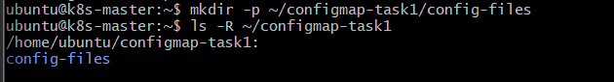

Step 1.2 — Create the first configuration file
cat > ~/configmap-task1/config-files/app.env <<'EOF'
APP_NAME=MyKubernetesApp
APP_PORT=8080
EOF
Verify:
cat ~/configmap-task1/config-files/app.env
Expected:
APP_NAME=MyKubernetesApp
APP_PORT=8080

Step 1.3 — Create the second configuration file
cat > ~/configmap-task1/config-files/database.env <<'EOF'
DB_HOST=mysql-service
DB_PORT=3306
EOF
Verify:
cat ~/configmap-task1/config-files/database.env
Expected:
DB_HOST=mysql-service
DB_PORT=3306
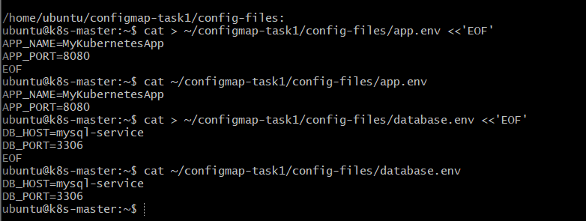

Step 1.4 — Check the directory
ls -l ~/configmap-task1/config-files
You should see:
app.env
database.env
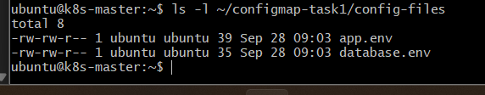

Step 1.5 — Create the ConfigMap from the directory
Run:
kubectl create configmap app-config \
--from-file=~/configmap-task1/config-files/
Expected:
configmap/app-config created
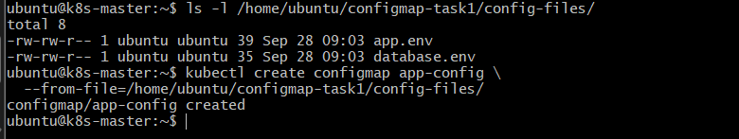
Here:
- app-config → ConfigMap name
- --from-file → tells Kubernetes to take data from files
- config-files/ → directory containing multiple files

Step 1.6 — Verify the ConfigMap
kubectl get configmap app-config
Then:
kubectl describe configmap app-config
You should see entries similar to:
Data
====
app.env:
----
APP_NAME=MyKubernetesApp
APP_PORT=8080

database.env:
----
DB_HOST=mysql-service
DB_PORT=3306
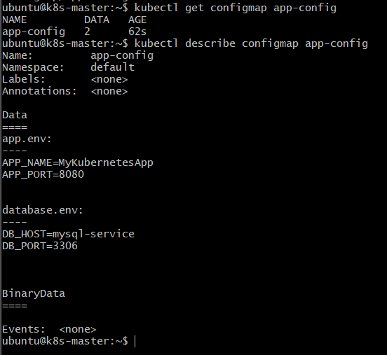

Important point
At this stage, Kubernetes has not yet created environment variables.
The ConfigMap currently contains:
app.env
database.env
The Pod will use envFrom to consume the ConfigMap.

Step 1.7 — Create the Pod YAML
Create:
cat > ~/configmap-task1/configmap-env-pod.yaml <<'EOF'
apiVersion: v1
kind: Pod
metadata:
name: configmap-env-pod
spec:
containers:
- name: nginx
image: nginx
envFrom:
- configMapRef:
name: app-config
EOF
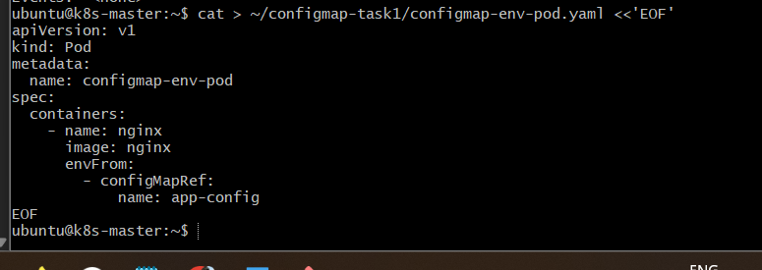

Step 1.8 – create the pod

kubectl apply -f ~/configmap-task1/configmap-env-pod.yaml

Step 1.9 - Verify environment variables
kubectl exec configmap-env-pod -- env | grep -E 'APP_NAME|APP_PORT|DB_HOST|DB_PORT'
Expected:
APP_NAME=MyKubernetesApp
APP_PORT=8080
DB_HOST=mysql-service
DB_PORT=3306

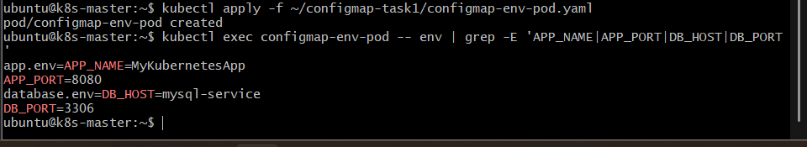

outcome

The ConfigMap was created from multiple files in a directory, and all configuration values were successfully injected into the Pod as environment variables.

Task 2: ConfigMap from File → Volume Mount

Objective
Create a ConfigMap from a configuration file, mount the ConfigMap as a volume inside a Pod, and verify that the configuration data is available as a file.

Implementation Steps

1. Create the configuration file
mkdir -p ~/configmap-task2

cat > ~/configmap-task2/app.conf <<'EOF'
APP_NAME=MyKubernetesApp
APP_ENV=production
APP_PORT=8080
EOF
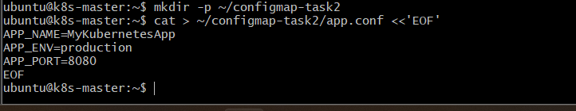

2. Create ConfigMap from the file
kubectl create configmap app-file-config \
--from-file=~/configmap-task2/app.conf

3. Create Pod YAML
cat > ~/configmap-task2/configmap-volume-pod.yaml <<'EOF'
apiVersion: v1
kind: Pod
metadata:
name: configmap-volume-pod
spec:
containers:
- name: nginx
image: nginx
volumeMounts:
- name: config-volume
mountPath: /etc/app-config
volumes:
- name: config-volume
configMap:
name: app-file-config
EOF

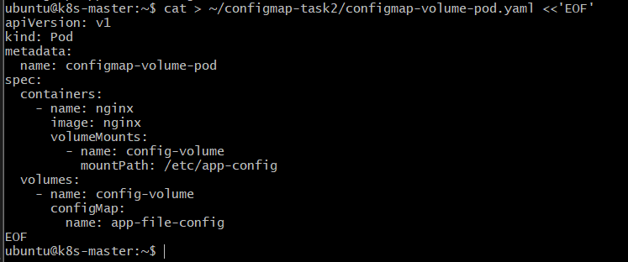

4. Create the Pod
kubectl apply -f ~/configmap-task2/configmap-volume-pod.yaml

5. Verify the configuration file inside the Pod
kubectl exec configmap-volume-pod -- ls -l /etc/app-config
Expected:
app.conf

6. Display the configuration
kubectl exec configmap-volume-pod -- cat /etc/app-config/app.conf
Expected:
APP_NAME=MyKubernetesApp
APP_ENV=production
APP_PORT=8080
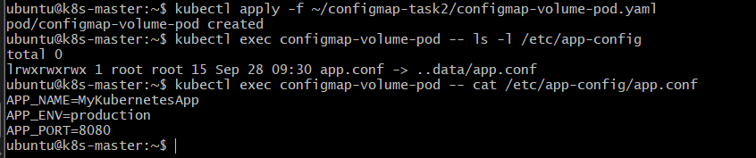

Outcome
The ConfigMap created from the configuration file was successfully mounted into the Pod as a volume, and the configuration was available inside the Pod as /etc/app-config/app.conf.

Task 3: Secret → Environment Variables

Objective
Create a Kubernetes Secret containing sensitive information such as a username and password, and inject the Secret values into a Pod as environment variables.

Implementation Steps

1. Create the Secret
kubectl create secret generic app-secret \
--from-literal=USERNAME=admin \
--from-literal=PASSWORD='MyPassword123'
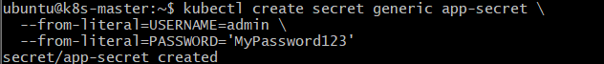

2. Create Pod YAML
cat > ~/secret-env-pod.yaml <<'EOF'
apiVersion: v1
kind: Pod
metadata:
name: secret-env-pod
spec:
containers:
- name: nginx
image: nginx
env:
- name: APP_USERNAME
valueFrom:
secretKeyRef:
name: app-secret
key: USERNAME
- name: APP_PASSWORD
valueFrom:
secretKeyRef:
name: app-secret
key: PASSWORD
EOF
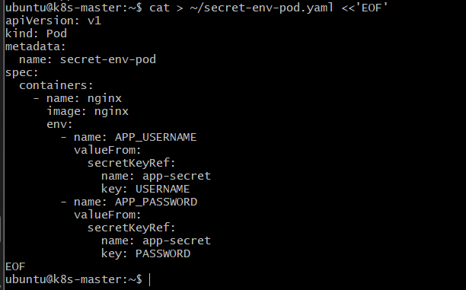

3. Create the Pod
kubectl apply -f ~/secret-env-pod.yaml

4. Verify the environment variables
kubectl exec secret-env-pod -- printenv APP_USERNAME
Expected:
admin
Verify password:
kubectl exec secret-env-pod -- printenv APP_PASSWORD
Expected:
MyPassword123
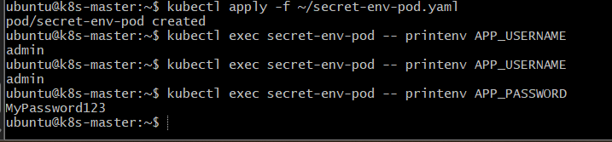

Outcome
The username and password were stored in a Kubernetes Secret and successfully injected into the Pod as environment variables.

Task 4: Secret YAML → Volume Mount

Objective
Create a Kubernetes Secret using a YAML file, mount the Secret as a volume inside a Pod, and verify that the Secret values are available as files.

Implementation Steps

1. Create Secret YAML
cat > ~/secret-volume.yaml <<'EOF'
apiVersion: v1
kind: Secret
metadata:
name: app-file-secret
type: Opaque
stringData:
username: admin
password: MyPassword123
EOF
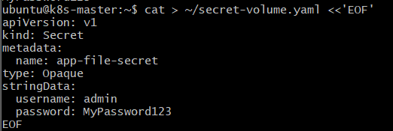

2. Create the Secret
kubectl apply -f ~/secret-volume.yaml

3. Create Pod YAML
cat > ~/secret-volume-pod.yaml <<'EOF'
apiVersion: v1
kind: Pod
metadata:
name: secret-volume-pod
spec:
containers:
- name: nginx
image: nginx
volumeMounts:
- name: secret-volume
mountPath: /etc/app-secret
readOnly: true
volumes:
- name: secret-volume
secret:
secretName: app-file-secret
EOF
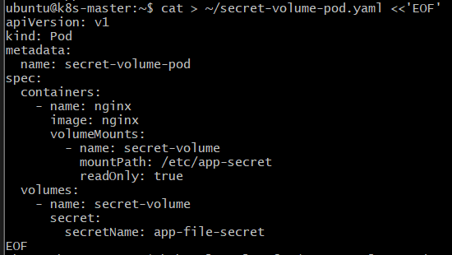

4. Create the Pod
kubectl apply -f ~/secret-volume-pod.yaml

5. Verify Secret files
kubectl exec secret-volume-pod -- ls -l /etc/app-secret
Expected:
password
username

6. Verify the Secret values
kubectl exec secret-volume-pod -- cat /etc/app-secret/username
expected: admin

kubectl exec secret-volume-pod -- cat /etc/app-secret/password
expected: Mypassword123

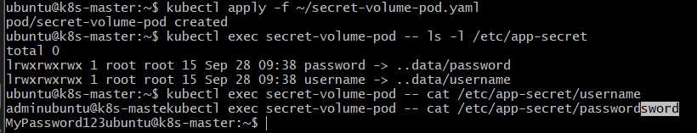

Outcome
The Secret was created using a YAML file, mounted into the Pod as a read-only volume, and the username and password were successfully available as separate files inside /etc/app-secret.

Task 5: ConfigMap as Environment Variables + Secret as Files

Objective
Inject a ConfigMap as environment variables and mount a Secret as files into the same Pod.

Implementation Steps

1. Create ConfigMap
kubectl create configmap app-settings \
--from-literal=APP_NAME=MyApplication \
--from-literal=APP_ENV=production
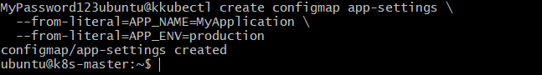

2. Create Secret YAML
cat > ~/app-secret.yaml <<'EOF'
apiVersion: v1
kind: Secret
metadata:
name: app-credentials
type: Opaque
stringData:
username: admin
password: MyPassword123
EOF
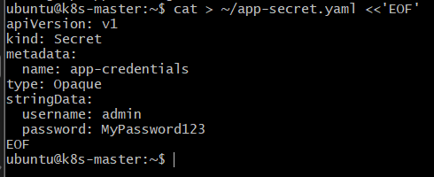

3. Create the Secret
kubectl apply -f ~/app-secret.yaml

4. Create Pod YAML
cat > ~/config-secret-pod.yaml <<'EOF'
apiVersion: v1
kind: Pod
metadata:
name: config-secret-pod
spec:
containers:
- name: nginx
image: nginx
envFrom:
- configMapRef:
name: app-settings
volumeMounts:
- name: secret-volume
mountPath: /etc/app-secret
readOnly: true
volumes:
- name: secret-volume
secret:
secretName: app-credentials
EOF
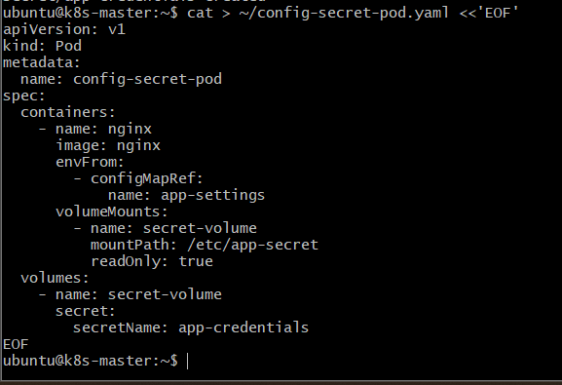

5. Create the Pod
kubectl apply -f ~/config-secret-pod.yaml

6. Verify ConfigMap environment variables
kubectl exec config-secret-pod -- env | grep -E 'APP_NAME|APP_ENV'
Expected:
APP_NAME=MyApplication
APP_ENV=production
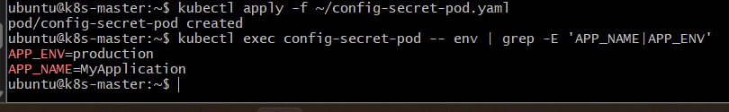

7. Verify Secret files
kubectl exec config-secret-pod -- ls -l /etc/app-secret
Expected:
password
username
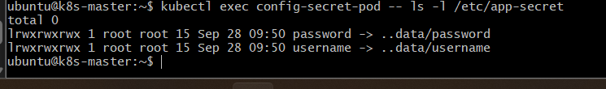

8. Verify Secret values
kubectl exec config-secret-pod -- cat /etc/app-secret/username
Expected:
admin
kubectl exec config-secret-pod -- cat /etc/app-secret/password
Expected:
MyPassword123

Outcome
The same Pod successfully consumed:
- ConfigMap → environment variables
- Secret → files through a volume mount
ConfigMap ──→ Environment Variables
│
Pod
│
Secret ───────→ /etc/app-secret/
├── username
└── password

